**UserRelationship Function Demo**

**Understanding Data and Relationships first:**

**DimDate Table:**

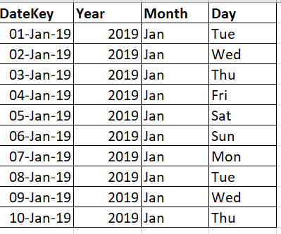

**FactInternetSales Table:**

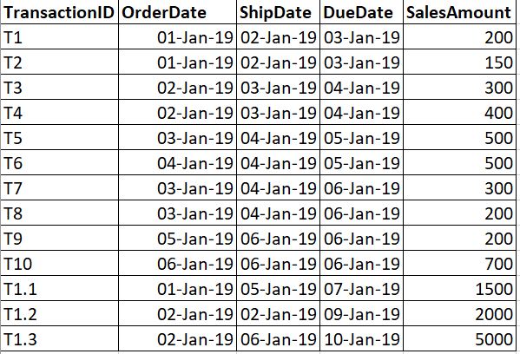

In Power BI:

Create all the 3 possible relationships as shown next:

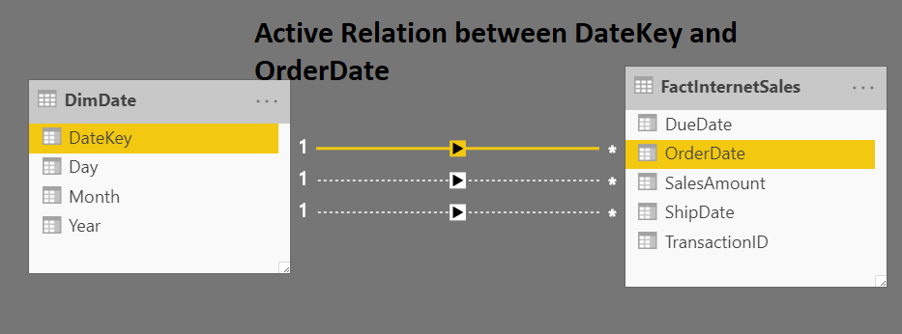

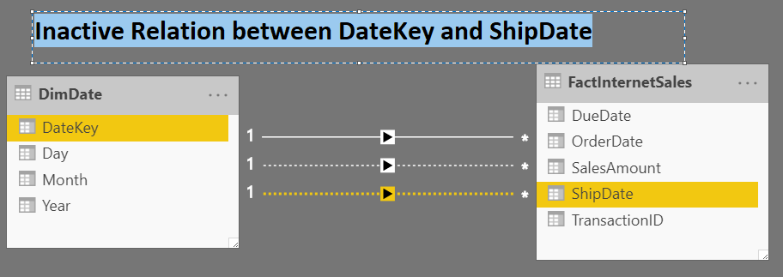

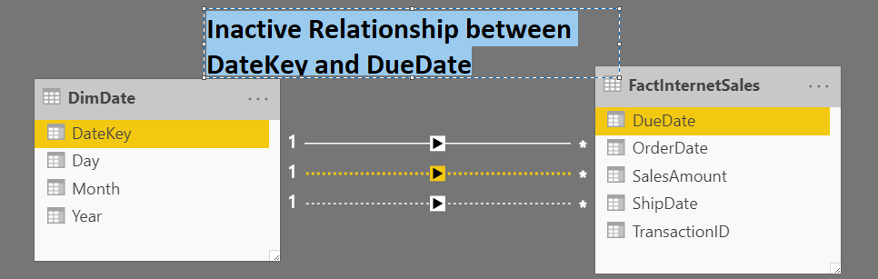

1. If we want Sum of FactInternetSales as per the active relationship, i.e. as per DateKey of DimDate and OrderDate of FactInternetSales, then it becomes very simple:

SalesByOrderDate := SUM ( FactInternetSales[SalesAmount] )

But what if we want the same sum as per any of the inactive relationship??

* Use the function **UseRelationship**

1. We want Sum of Sales as per **ShipDate** of FactInternetSalesand **DateKey** DimDate **inactive** relation:

Create a new measure:

SalesByShipDate =

CALCULATE (

SUM ( FactInternetSales[SalesAmount] ),

**USERELATIONSHIP** (

FactInternetSales[**ShipDate**],

DimDate[**DateKey**]

)

)

1. We want Sum of Sales as per **DueDate** of FactInternetSalesand **DateKey** DimDate **inactive** relation:

SalesByDueDate =

CALCULATE (

SUM ( FactInternetSales[SalesAmount] ),

**USERELATIONSHIP** (

FactInternetSales[**DueDate**],

DimDate[**DateKey**]

)

)

1. Place a Table and place the members as shown next 🡪

